Schedule a Pick-up on FedEx.com
Scroll over the Ship Tab. Then Click on the “Schedule and Manage Pickups “when it appears.
If you haven’t already you will need to log-in. The screen below will then appear. From here a pickup can be scheduled.
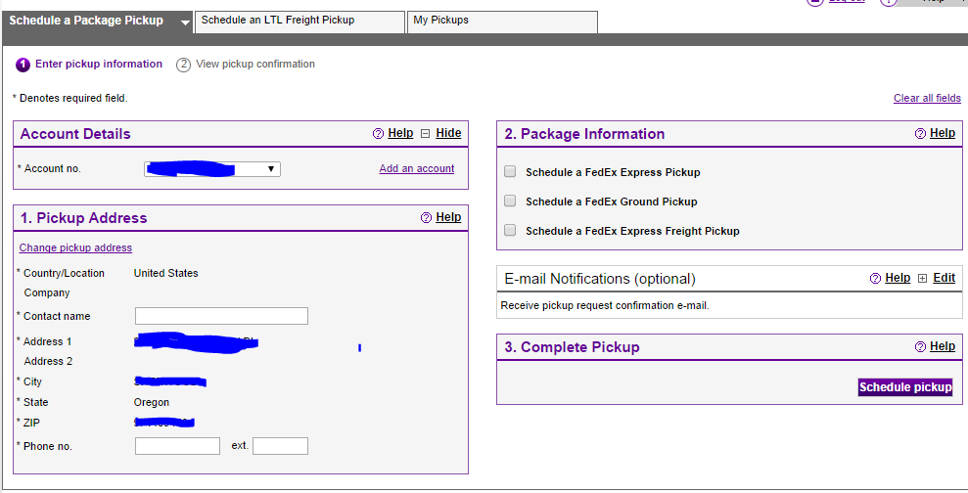
Pick-ups can also be scheduled by call 800-GoFedEx (800-463-3339)

