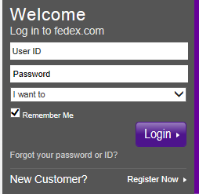

**How to register your account on Fedex.com**

**Click on Register now button**

**Next Screen**

**Click on Take Account Online**

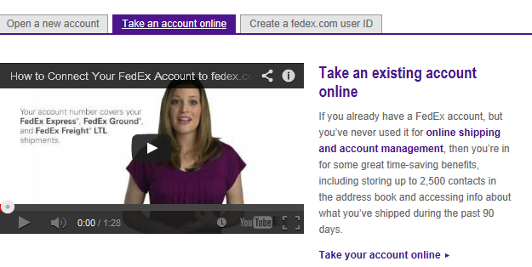

**Then Click on Register now button here**

**Next Step is to register and setup a user name and password**

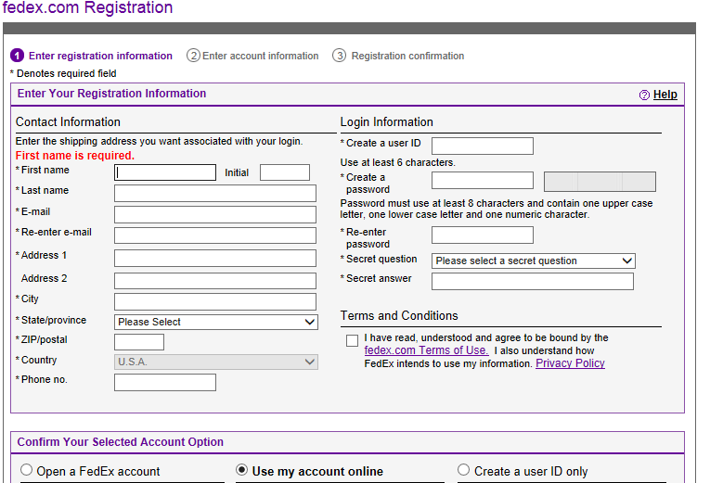

**Be sure to use this Use My Account Online button. On the next screen you will be asked for** **the account number.**

**From here you should be able to ship.**