Frequently asked questions:

Q. What is the website I order on now? A. http://business.officedepot.com
Q. What is my login? A. Your login should be the same as you used on the officemaxworkplace website. You will receive the login and password from a specialist on the migration team. In some cases, the login was changed slightly.
Q. I never received my login, how can I get one? You can contact Mitchel.muse@officedepot.com. Please advise your contact information, (name, email, shipping address, phone.) and your respective department you work for. If you have your account number, please include it. Do you have an approver? If so, include their email address. Please indicate how you would like to pay for your product. Billing or P-Card.
Q. Can I still use officemaxworkplace.com? A. No, all accounts have transitioned to Office Depot: http://business.officedepot.com.
Q. I had shopping lists that I would like on the new platform, can I get them? A. Yes, send an email to wendy.mccune@officedepot.com with your Office Max login and your Office Depot login, with a request to load the shopping list onto http://business.officedepot.com.
Q. How can I find my contract items? A. Contract items will now be designated by a yellow starburst that reads “Best Value.” You can use the search feature, or any of the category links to search for product. When you get a list, you can select to sort by “Best Value”. (As shown below.)
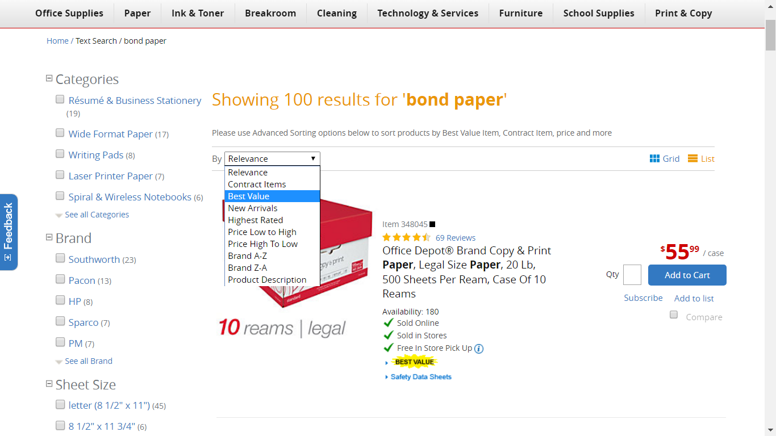
Q. How do I order? Place returns? A. Please browse through our self-reviewable videos: https://business.officedepot.com/customerservice/videodemos/index.do
Q. What do I do if I have an issue? A. You can review the customer support site. https://business.officedepot.com/customerservice/index.do
Chat online, OR contact customer support at the numbers below.
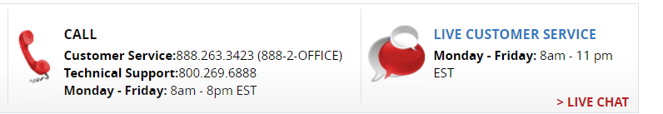
If you are still not satisfied, please contact Mitchel Muse. Mitchel.muse@officedepot.com
Q. How do I get an invoice? A. You will no longer be auto-generated email invoices. You can email our team for these. Please allow 3-5 business days for receipt. INV-PODS@OfficeDepot.com (Or options below)
Please note: Many users who order with credit card are fine with simply obtaining a receipt for their order. This can be completed online by saving or printing their order from “order history”. Others have needed a document to read “invoice”. This case you can obtain this on “Bill Management”. See directions for both below:
Order History:
Directions:
Step 1. In http://business.officedepot.com, you will go to “Orders”. 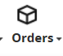
Step 2. Find the link under “Order Number”, click the order number: 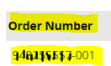
Step 3. Slide down, select “Print Order”. 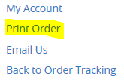
Bill Management:
Directions:
Step 1. In http://business.officedepot.com, you will need your order number.
Step 2. Go to My Account
Step 3. Click Online Reporting 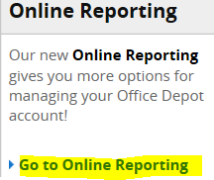
Step 4. Click “Bill Management” (Blue link)

Step 5. In “search” column: See “Search By” and click the drop down. (this is defaulted to “customers”) You will update it to “INVOICES”.
Step 6. Just to the right of drop down (that now reads invoices) you will enter in your order number. Please note it is very important to have your invoice number with no dashes and no spaces at end of number. Should look like this when you enter it: 123456789001: then hit “go”
Step 6. Your invoice number will show now under Transaction Number. 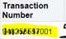 Click the order number here.
Step 7. You will slide to right and can choose to email this to your email by selecting “Email/Fax Copy”
Step 8. Check the email box, and enter your email address:
Step 9. Click submit.
You will receive an email with your invoice.

Q. Do you have online training? A. Yes, you can click the link and login to get directly to the online training.
https://business.officedepot.com/customerservice/videodemos/index.do
You can also go to bulletin board and see a live demo.

